SIMATS ENGINEERING
ASSESSMENT TOOL 2

COURSE CODE: CSA14 COURSE NAME: Compiler Design

COURSE OUTCOME COVERED

CO1: Apply lexical analysis for token specification and recognition using LEX tool (BL3)

Assessment Tool Weightage: 20%

Duration :60 Mins
On class
QUESTIONS: Total Marks:50

Annexure A

ERROR ANALYSIS TASK

Code of Conduct:

I Y. Harsha Vardhan Reddy (192425227) ____________________ (Name / Reg No) certify that this submission is my original work and that I have adhered to the guidelines specified for this assessment.
I understand that any violation of academic integrity rules will result in disciplinary action.

Signature of the student:

Y.H.V.R

Annexure A

ERROR ANALYSIS TASK

Q1. The following C program is intended to perform string processing, function calls, array manipulation, conditional execution, pointer operations, switch-case selection, and loop execution. However, the program contains several errors introduced during different phases of compilation, including lexical, syntax, semantic, logical, and runtime errors.

Given Program
#include <stdio.h>
#include <string.h>

int findLength(char str[])
{
return strlen(str);
}

int main()
{
char name[20] = "Compiler"

int count;

count = findLength();

if(count > 5
{
printf("Length is greater than 5\n");
}

int marks[4] = {85, 90, 75, 80};

printf("%d\n", marks[4]);

int choice = 2;

switch(choice)
{
case 1:
printf("Option 1\n");
break;

case 2
printf("Option 2\n");
break;

default:
printf("Invalid Choice\n");
}

int *ptr;
printf("%d\n", *ptr);

int total = 100;
int students = 0;

float average = total / students;

int i = 1;

while(i <= 5)
{
printf("%d\n", i);
}

return 0;
}

Tasks

- Identify all errors in the program. Mention the line number, error type, and reason for each error. (5 Marks)
- Line 10: Missing semicolon ; after the string initialization char name[20] = "Compiler".
- Line 12: Function findLength() is called without passing the required argument name.
- Line 13: Missing closing parenthesis ) in the condition if(count > 5.
- Line 18: Array index out of bounds: marks[4] accesses the 5th element of a 4-element array marks[4].
- Line 24: Missing colon : after case 2 in the switch statement.
- Line 30: Dereferencing an uninitialized pointer ptr (*ptr), leading to undefined behavior/garbage value reading.
- Line 33: Division by zero error: total / students where students = 0.
- Line 34–37: Infinite loop: The variable i is initialized to 1, but i is never incremented inside the while(i <= 5) block.

- Classify the identified errors as Lexical, Syntax, Semantic, Logical, or Runtime errors in a suitable table. (5 Marks)
  - Line 10: Missing semicolon ';' at end of declaration | Syntax Error
  - Line 12: Function call missing required argument | Semantic Error Line 13: Unmatched parenthesis in if-condition | Syntax Error
  - Line 18: Array index out of bounds ('marks[4]') | Logical / Runtime Error Line 24: Missing colon ':' after 'case 2' | Syntax Error
  - Line 30: Dereferencing wild/uninitialized pointer ('*ptr') | Runtime / Logical Error
  - Line 33: Division by zero ('total / students') | Runtime Error
  - Line 34: Loop counter 'i' not incremented (Infinite loop) | Logical Error

- Explain at which phase of compilation each category of error is detected. Also mention which errors are detected only during execution. (4 Marks)
Compiler Phase Detection:
• Syntax Errors (Lines 10, 13, 24): Detected during the Syntax Analysis (Parsing) phase when token sequences violate C grammatical rules.
• Semantic Errors (Line 12): Detected during the Semantic Analysis phase through type checking and function prototype matching.
• Logical Errors (Lines 18, 34–37): Typically not caught as fatal compilation errors, though modern compilers may issue static analysis warnings.

Errors Detected ONLY During Execution (Runtime):
• Division by Zero (Line 33): Causes an immediate floating-point exception / crash during program execution.
• Uninitialized Pointer Dereference (Line 30): Causes a segmentation fault or reads garbage memory dynamically at runtime.
• Array Out-of-Bounds Access (Line 18): Results in undefined memory access during program execution.

- Rewrite the program after correcting all the errors so that it executes successfully. (4 Marks)
#include <stdio.h>
#include <string.h>

int findLength(char str[])
{
return strlen(str);
}

int main()
{
char name[20] = "Compiler"; // Added missing semicolon
int count;
count = findLength(name); // Passed required argument 'name'

if(count > 5) // Added missing closing parenthesis
{
printf("Length is greater than 5\n");
}

int marks[4] = {85, 90, 75, 80};
printf("%d\n", marks[3]); // Corrected index to valid range (0 to 3)

int choice = 2;
switch(choice)
{
case 1:
printf("Option 1\n");
break;
case 2: // Added missing colon
printf("Option 2\n");
break;
default:
printf("Invalid Choice\n");
}

int value = 10;
int *ptr = &value; // Properly initialized pointer
printf("%d\n", *ptr);

int total = 100;
int students = 5; // Fixed division by zero by giving valid student count
float average = (float)total / students;

int i = 1;
while(i <= 5)
{
printf("%d\n", i);
i++; // Incremented loop counter to prevent infinite loop
}

return 0;
}

Output:
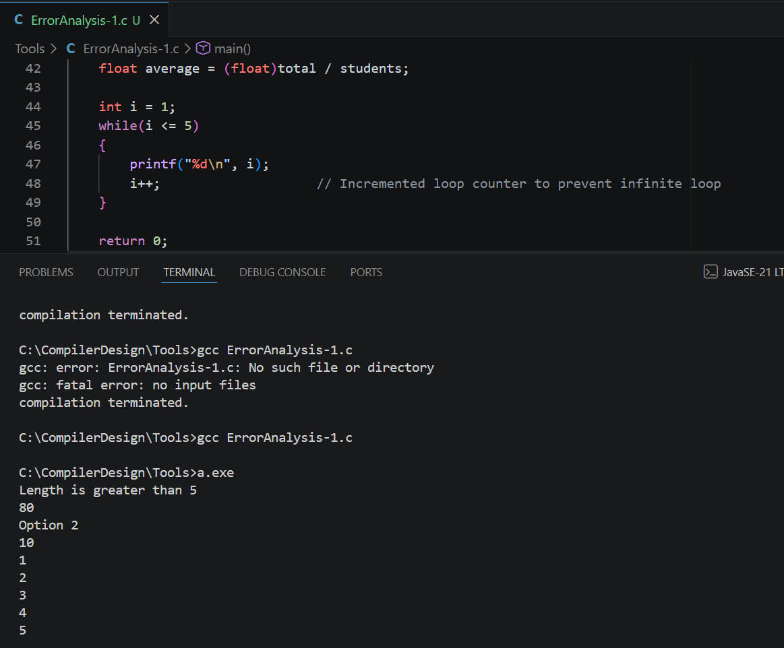

- Suggest any three compiler features or warnings that can help detect such programming errors before execution. (2 Marks)
1. Compiler Warning Flags (-Wall, -Wextra): Enabling diagnostic flags in compilers (like GCC/Clang) alerts developers to uninitialized variables (-Wuninitialized), unused variables, and missing return values prior to execution.
2. Static Code Analysis (-Warray-bounds, SAST Tools): Built-in compiler static analyzers evaluate execution paths to detect out-of-bounds array access and potential division-by-zero risks before compilation completes.
3. Address Sanitizer (-fsanitize=address): A compiler instrumentation tool that inserts runtime checks to instantly detect wild pointer dereferences, heap/stack buffer overflows, and memory leaks.

Q2. The following C program is intended to perform function calls, array processing, conditional execution, switch-case selection, and loop operations. However, several syntax errors have been intentionally introduced by violating the grammatical rules of the C language. These errors include missing delimiters, unmatched parentheses, incorrect control structures, malformed function definitions, and incomplete statements. Such errors are normally detected during the syntax analysis (parsing) phase of a compiler.

Carefully examine the program and answer the questions that follow.

Given Program
#include <stdio.h>

int maximum(int x, int y
{
if(x > y)
return x;
else
return y;
}

int main()
{
int marks[5] = {70, 80, 90, 85, 95};

int max = maximum(marks[0], marks[1]);

switch(max)
{
case 80:
printf("Maximum is 80\n")
break;

case 90
printf("Maximum is 90\n");
break;

default:
printf("Other Value\n");
}

do
{
printf("%d\n", max);
max--;
while(max > 75);

if(max == 75)
printf("Limit Reached\n"
}

return 0;

Tasks

- Identify all syntax errors in the program. Mention the line number and reason for each error. (4 Marks)
1. Line 3: Missing closing parenthesis ')' in the function declaration 'int maximum(int x, int y'.
2. Line 16: Missing semicolon ';' at the end of the statement 'printf("Maximum is 80\n")'.
3. Line 18: Missing colon ':' after the case label 'case 90'.
4. Line 26: Missing closing brace '}' for the 'do-while' loop block before the 'while' condition.
5. Line 28: Missing closing parenthesis ')' in the condition 'printf("Limit Reached\n"'.

- Classify the identified syntax errors under the appropriate categories and present them in a table. (3 Marks)
- Line 3: Unmatched parenthesis in function header | Malformed Function Definition Line 16: Missing semicolon ';' after printf | Missing Delimiter
- Line 18: Missing colon ':' after case 90 | Incorrect Control Structure
- Line 26: Missing block closing brace '}' before while-condition | Incomplete Statement / Structure
- Line 28: Missing closing parenthesis ')' in printf statement | Unmatched Parentheses

- Correct the syntax errors and rewrite the complete program. (4 Marks)
#include <stdio.h>

int maximum(int x, int y) // Added missing closing parenthesis
{
if(x > y)
return x;
else
return y;
}

int main()
{
int marks[5] = {70, 80, 90, 85, 95};
int max = maximum(marks[0], marks[1]);

switch(max)
{
case 80:
printf("Maximum is 80\n"); // Added missing semicolon
break;
case 90: // Added missing colon
printf("Maximum is 90\n");
break;
default:
printf("Other Value\n");
}

do
{
printf("%d\n", max);
max--;
} while(max > 75); // Added missing brace '}' for do-while loop

if(max == 75)
printf("Limit Reached\n"); // Added missing closing parenthesis & semicolon

return 0;
}
Output:
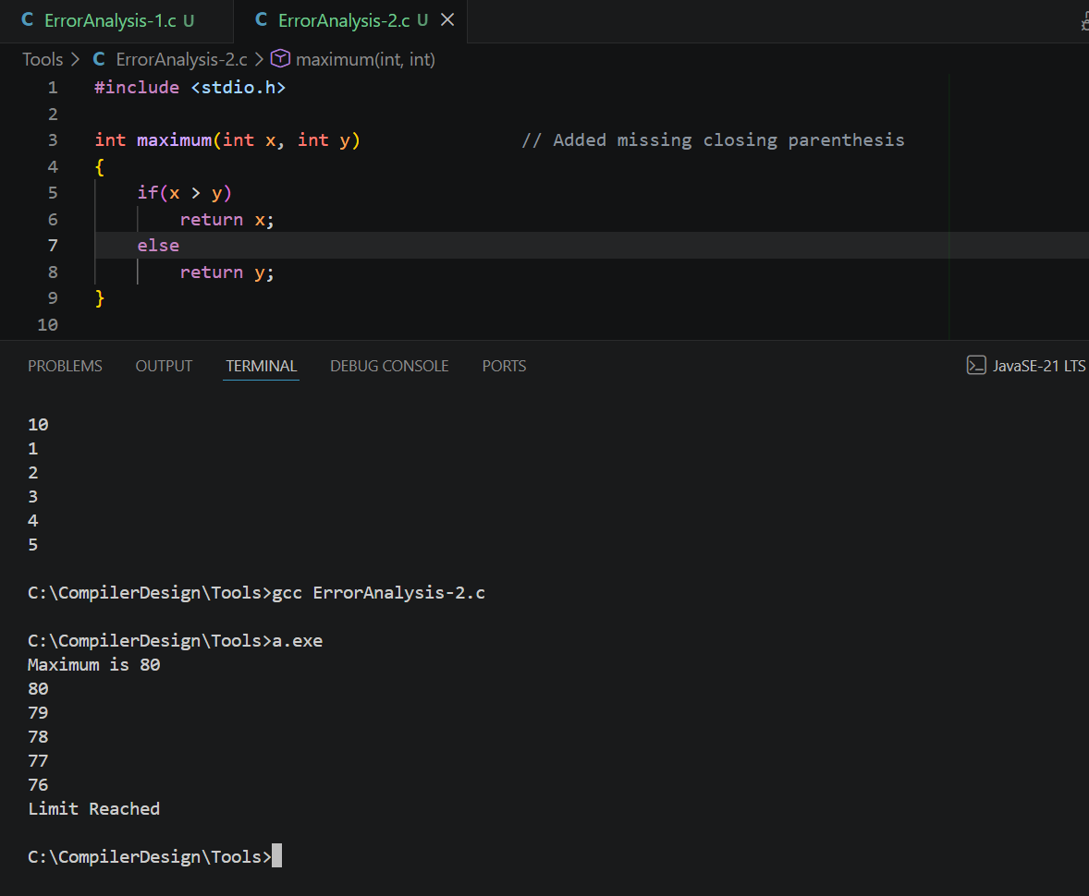

- Explain how the parser detects syntax errors and how error recovery enables further parsing. (2 Marks)
Parser Detection:
• During the syntax analysis phase, the parser processes tokens generated by the lexical analyzer against the context-free grammar rules of C.
• If a sequence of tokens violates grammar rules (e.g., expecting a ')' or ';' but finding a different token), the parser reports a syntax error and flags the failure.

Error Recovery:
• Panic Mode Recovery: Upon encountering an error, the parser discards incoming tokens one by one until it hits a "synchronizing token" (such as a semicolon ';' or closing brace '}'). Once found, it clears the local error state and resumes normal parsing.
• Phrase-Level Recovery: The parser replaces or inserts missing tokens (e.g., virtually inserting a missing semicolon) locally to allow compilation to proceed without getting stuck in an infinite loop.

- Suggest any two improvements that can help a compiler generate better syntax error messages. (2 Marks)
1. Precise Context & Inline Visual Pointers: Modern compilers (like Clang/GCC) use visual carets (^) alongside color-coded source lines to pinpoint the exact character column where a delimiter or parenthesis is missing.
2. Intelligent Fix-It Suggestions (Did You Mean? Hints): Incorporating ML/heuristic-based diagnostic engines that analyze common syntax patterns to suggest exact corrections (e.g., "expected ':' after case label", "did you mean to insert ')' here?").

Q3. The following C program is intended to perform factorial computation, function calls, array processing, pointer manipulation, conditional execution, switch-case selection, and loop operations. However, the program contains several errors introduced during different phases of compilation and execution, including lexical, syntax, semantic, intermediate code generation, code optimization, and runtime errors.

Carefully examine the program and answer the questions that follow.

Given Program
#include <stdio.h>

int factorial(int n)
{
if(n <= 1)
return 1;

return n * factorial(n - 1);
}

int main()
{
int @num = 5;

int value = 10

int result;

result = factorial();

if(result >= 100)
{
printf("Large Number\n");
}

switch(result)
{
case 24:
printf("Factorial of 4\n");
break;

case 120
printf("Factorial of 5\n");
break;

default:
printf("Other Value\n");
}

int numbers[5] = {2,4,6,8,10};
printf("%d\n", numbers[5]);

int *ptr;
printf("%d\n", *ptr);

int a = 50;
int b = 0;
int c = a / b;

int sum = result + 0 + value;

int i = 1;
while(i <= 5)
{
printf("%d\n", i);
}

return 0;
}

Tasks

- Identify all the errors in the program. Mention the line number, error type, and reason for each error. (4 Marks)
1. Line 10: Invalid character '@' in variable identifier name 'int @num = 5' (lexical/syntax error).
2. Line 11: Missing semicolon ';' at the end of declaration 'int value = 10'.
3. Line 13: Function 'factorial()' called without passing the required argument 'n'.
4. Line 23: Missing colon ':' after case label 'case 120'.
5. Line 30: Array index out of bounds; 'numbers[5]' accesses the 6th element of a 5-element array.
6. Line 32: Dereferencing an uninitialized wild pointer 'ptr' ('*ptr').
7. Line 35: Division by zero error where 'a' (50) is divided by 'b' (0).
8. Line 36: Redundant arithmetic identity operation ('+ 0') during expression evaluation (optimizer issue).
9. Line 37–40: Infinite loop because loop counter 'i' is initialized to 1 but never incremented inside the 'while(i <= 5)' block.

- Classify the identified errors according to the appropriate compiler phase (Lexical, Syntax, Semantic, Intermediate Code Generation, Code Optimization, and Runtime) using a suitable table. (4 Marks)
- Line 10: Invalid character '@' in identifier 'int @num' | Lexical Analysis
- Line 11: Missing semicolon ';' after declaration | Syntax Analysis
- Line 13: Function call missing required parameter | Semantic Analysis
- Line 23: Missing colon ':' after 'case 120' | Syntax Analysis
- Line 30: Array index out of bounds ('numbers[5]') | Runtime / Semantic Analysis
- Line 32: Dereferencing uninitialized pointer ('*ptr') | Runtime Error
- Line 35: Division by zero ('a / b') | Runtime Error
- Line 36: Redundant identity operation ('+ 0') | Code Optimization
- Line 37: Missing loop increment (Infinite loop) | Logical / Intermediate Code Gen

- Explain how the compiler processes the program by identifying the errors detected during each compilation phase and those detected only at runtime. (3 Marks)

Compilation Phase Detection:
• Lexical Analysis Phase: Detects invalid tokens or illegal characters (such as '@' in Line 10) that do not conform to the language's token rules.
• Syntax Analysis Phase: Detects structural violations of C grammar rules, such as missing semicolons (Line 11) and missing colons in switch-cases (Line 23).
• Semantic Analysis Phase: Detects type mismatches, invalid function call signatures (Line 13 missing parameters), and scope resolution errors.
• Code Optimization Phase: Identifies inefficiencies in generated intermediate code, such as dead code or algebraic identities like adding 0 (Line 36), folds constants, and optimizes away unnecessary instructions.

Errors Detected ONLY During Execution (Runtime):
• Division by Zero (Line 35): Cannot always be evaluated statically if variables are set dynamically, resulting in an execution exception (SIGFPE).
• Wild Pointer Dereference (Line 32): Involves reading/writing an arbitrary dynamic memory address at runtime, causing a segmentation fault (SIGSEGV).
• Out-of-Bounds Memory Access (Line 30): Accesses memory beyond the allocated array boundaries during program execution.

- Rewrite the complete corrected program so that it compiles and executes without errors. (2 Marks)
#include <stdio.h>

int factorial(int n)
{
if(n <= 1)
return 1;
return n * factorial(n - 1);
}

int main()
{
int num = 5; // Removed invalid '@' symbol
int value = 10; // Added missing semicolon
int result;

result = factorial(num); // Passed required argument 'num'

if(result >= 100)
{
printf("Large Number\n");
}

switch(result)
{
case 24:
printf("Factorial of 4\n");
break;
case 120: // Added missing colon
printf("Factorial of 5\n");
break;
default:
printf("Other Value\n");
}

int numbers[5] = {2, 4, 6, 8, 10};
printf("%d\n", numbers[4]); // Fixed index to valid range (0 to 4)

int *ptr = &value; // Properly initialized pointer
printf("%d\n", *ptr);

int a = 50;
int b = 2; // Fixed division by zero
int c = a / b;

int sum = result + value; // Removed redundant '+ 0' addition

int i = 1;
while(i <= 5)
{
printf("%d\n", i);
i++; // Incremented loop counter to fix infinite loop
}

return 0;
}

Output:
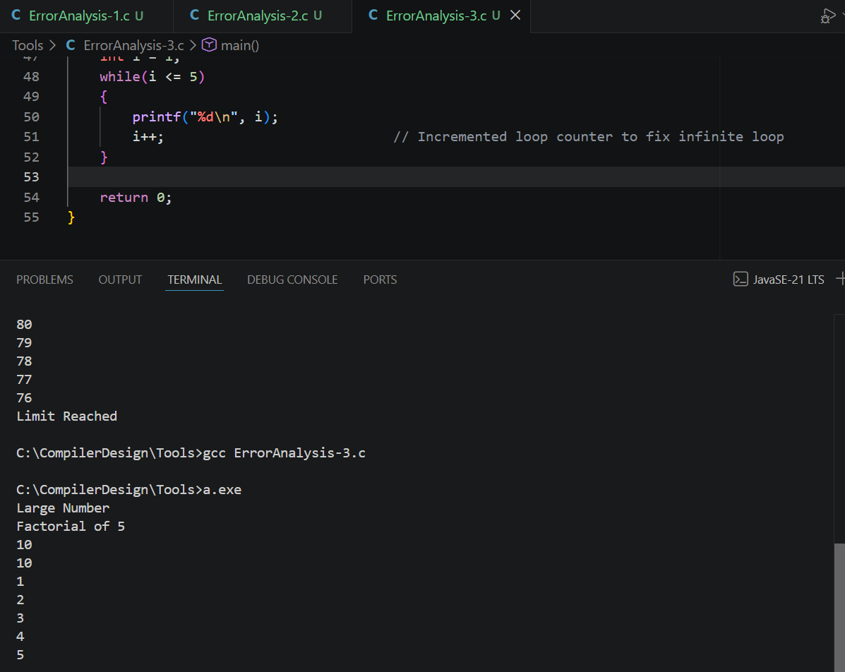
- Suggest any two improvements in compiler design or optimization techniques that could detect or prevent such errors before program execution. (2 Marks)
1. Constant Propagation and Dead Code Elimination: Advanced optimization passes can evaluate expression graphs statically (e.g., evaluating '50 / 0') at compile time to trigger a compile-time arithmetic warning/error, while simultaneously folding redundant operations like 'x + 0' into 'x'.
2. Static Control Flow Analysis & Data-Flow Tracking: Modern compilers utilize static single assignment (SSA) forms and path-sensitive analysis to trace pointer initializations and loop counter updates, warning developers before compilation completes about uninitialized pointer usage or non-terminating loops.

RUBRICS FOR CALCULATION:

Criteria | Weightage | Level 4 (Exemplary) | Level 3 (Proficient) | Level 2 (Developing) | Level 1 (Beginning)
Error Identification | 20% | Accurately identifies all errors with clear understanding of issues | Identifies most errors with minor omissions | Identifies limited errors; some are missed | Fails to identify key errors
Root Cause Analysis | 30% | Clearly explains underlying causes with strong technical reasoning | Explains causes with moderate clarity | Partial explanation; weak reasoning | Unable to identify causes of errors
Correction & Justification | 25% | Provides correct solutions with strong justification and logic | Provides correct corrections with some justification | Corrections are partially correct or weakly justified | Incorrect or no corrections provided
Application of Concepts | 15% | Effectively applies relevant concepts to analyze and resolve errors | Applies concepts with minor errors | Limited application; requires guidance | Unable to apply concepts
Clarity & Presentation | 10% | Presents analysis clearly, logically, and systematically | Generally clear with minor issues | Lacks clarity or proper structure | Poor presentation and difficult to understand

